Task 1 : Binary file created : 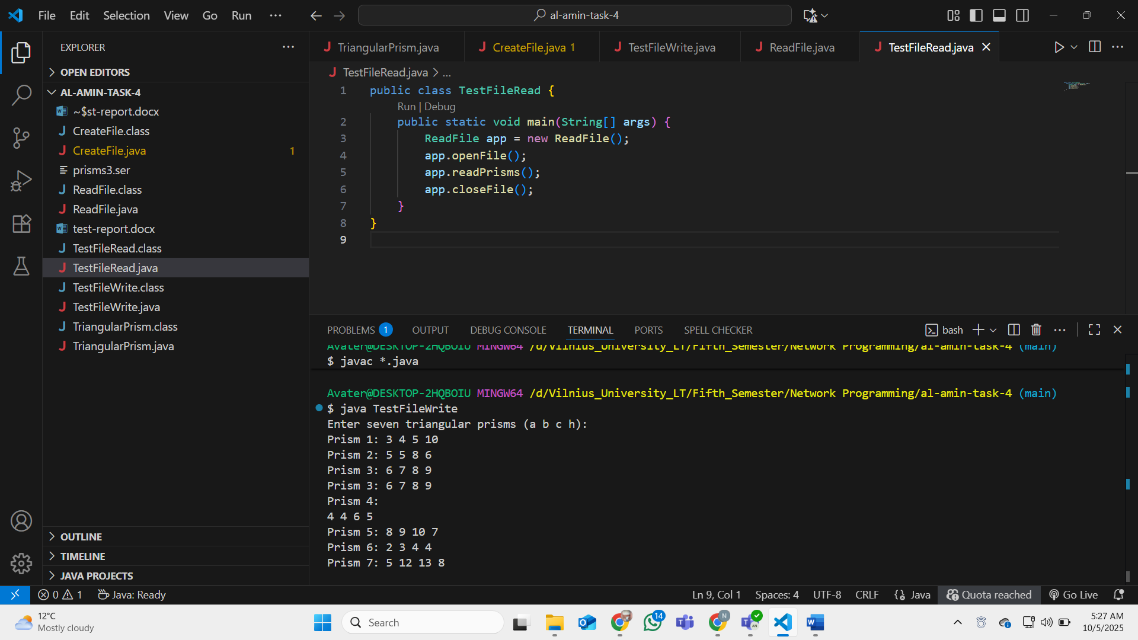
Showing it on the screen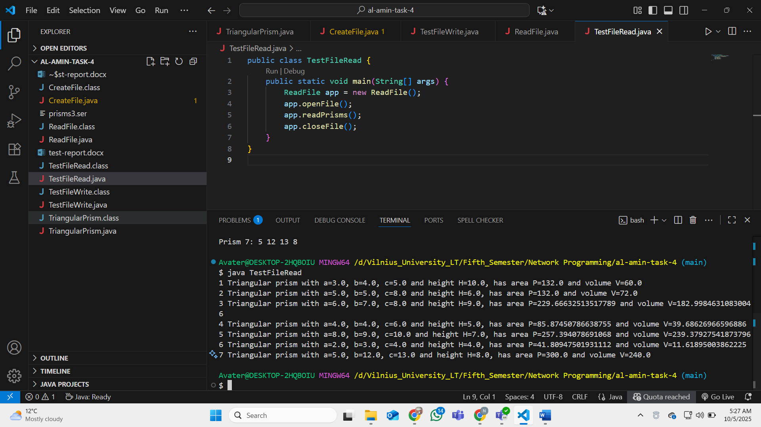
Task 2 :
Api used : https://restcountries.com/v3.1/independent?status=true
From rest countries .
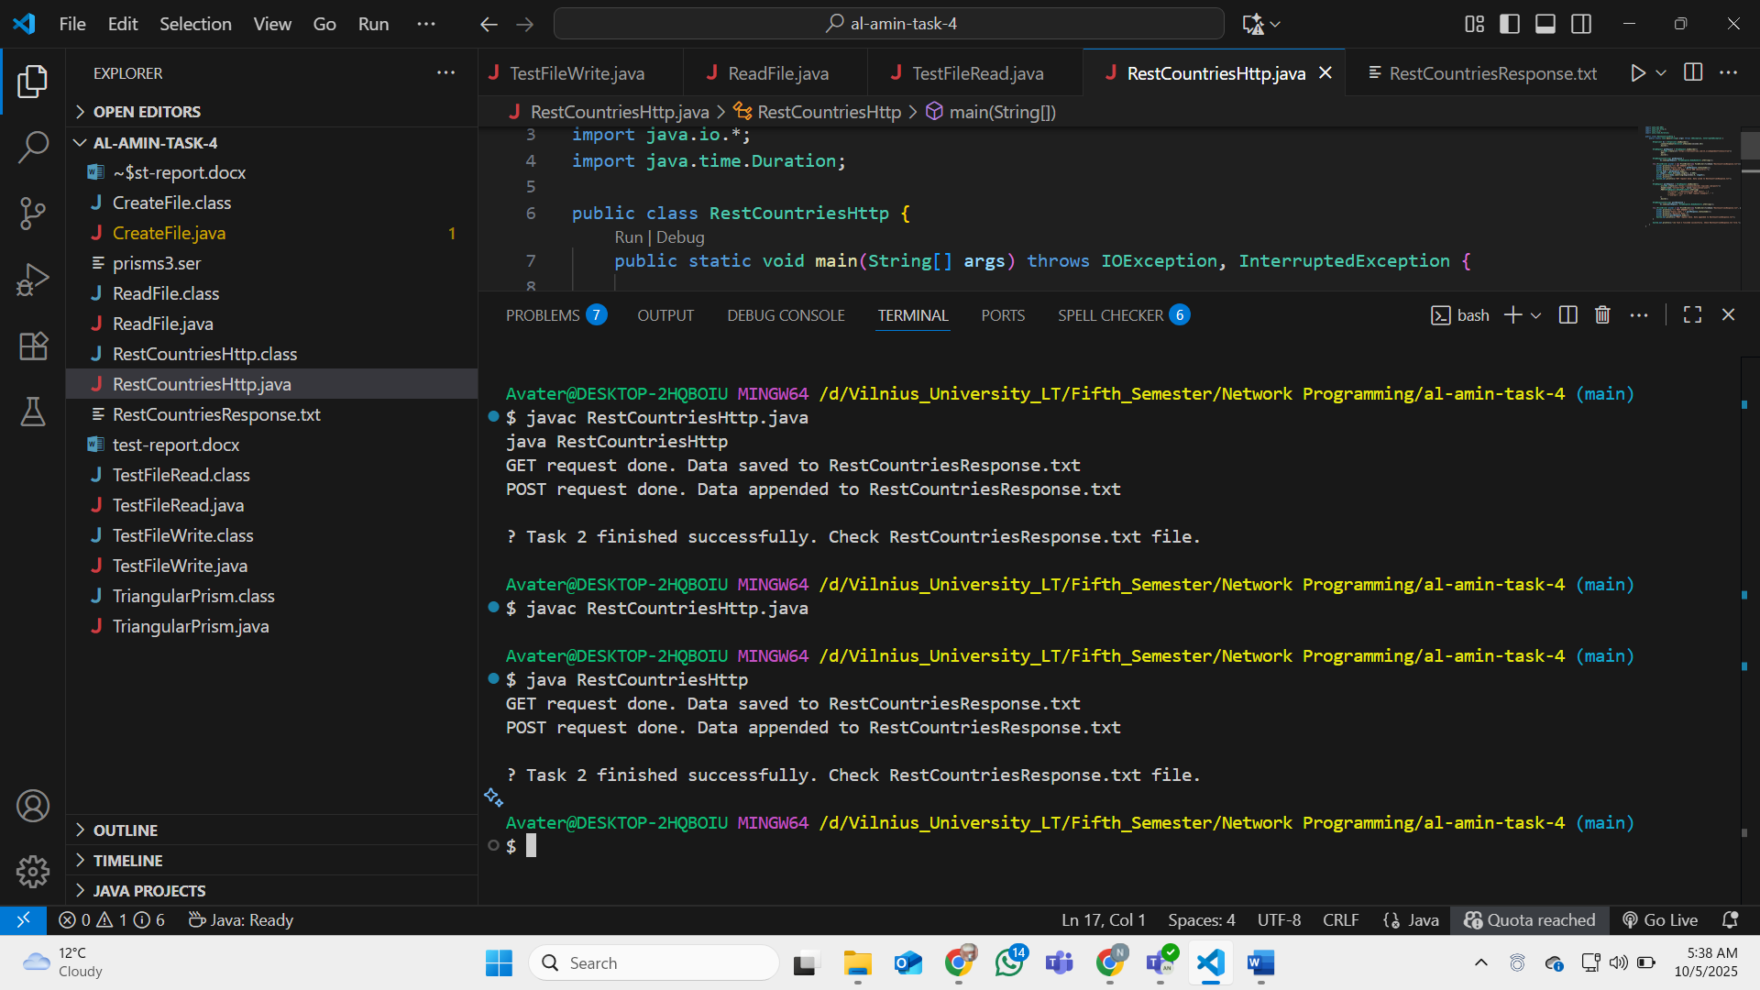

Txt file 